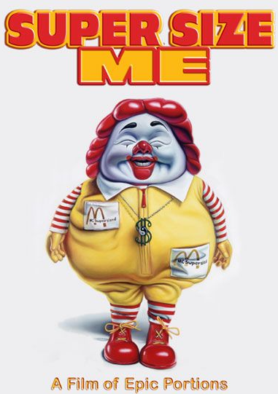
SUPERSIZE ME
COMPREHENSION QUESTIONS
PREVIDEO QUESTIONS:
- How often do you eat fast food?

- Do you believe that fast food is really that bad for you?

- What is your favorite fast food restaurant and fast food meal?

- Why do you think people are drawn to fast food?

Video Comprehension Questions:

- McDonald’s founder, Ray Kroc states in the beginning, “Look after the customer and the business will take care of itself.” What do you think he meant by this and do you find any validity to it?

- Do you think people should be able to sue McDonald’s for making them overweight? Why or why not?

- Where does personal responsibility kick into the lawsuit that these two girls faced?

- Do you think the 30 day challenge would be enough time to prove Morgan’s point?

- Why did he check with three different doctors before he began his study? Do you find this to be a smart idea? Why?

- Why did he go to a dietician?

- What did the exercise physiologist measure on Morgan?

- How many steps make a mile according to the walking editor?

- How many miles does the walking Editor say he must limit to each day?

- What are the rules to this challenge?

- What do you think about the size differences over the years?

- Is “fat the new tobacco?”

- What do you think about the fact of one out of three children will be born in the 2000 will have diabetes?

- Who is Jared Fogle and how much did he weigh?

- What did the John Robbins say about his childhood and how it made him feel? What did he do to continue the vicious cycle?

- What happened to the Ben and Jerry’s Ben?

- According to his rules, why can’t Morgan take a multi vitamin?

- How much did he gain in five days? What did you think about this weight gain?

- What is a McFrankenstein?

- How Morgan’s mental health day 9? What’s his mind set after he eats?

- Dom Gorske is the Big Mac enthusiast. How many big Macs did he eat in one year?

- How many food advertisements does a kid see each year?

- What did you think about the picture association with the children?

- What feeling did the kids give off when they saw Ronald McDonald?

- Did anything about the nutrition information and how it is relayed at McDonald’s bother you? Why or Why not?
- What did you think about the lunchroom scene about what kids eat and what is being served? Is choice still important? What is being served? What else can you if these are the only options a shool is offering?

- Do all cooks at school actually cook? Who supplies all of the food for schools?

- What did you think about the connection between healthy food and behavior?

- Why isn’t everyone supplying healthy food when it costs the same?

- What happened to the man in the hospital?

- What did you think about gastric bypass surgery? Do you think there is a better alternative?

- What scare did Morgan face?

- What did you think about the family that didn’t know the pledge of allegiance but knew the Big Mac Slogan?

- What was his final weight?

- How much sugar and fat did he consume?

- What positive influence did this documentary create?

- Did this documentary change the way you think about fast food at all?

